Fundamentals Of Data Science-DSA0410
Lab Experiments

M. Haari
192472050

Experiment-6
Program:
prices = [50, 30, 20]
quantities = [2, 3, 1]
discount_rate = 10
tax_rate = 5
total = 0
for price, qty in zip(prices, quantities):
total += price * qty
discount_amount = total * (discount_rate / 100)
after_discount = total - discount_amount
tax_amount = after_discount * (tax_rate / 100)
final_amount = after_discount + tax_amount
print("Total cost to pay:", final_amount)

Output:
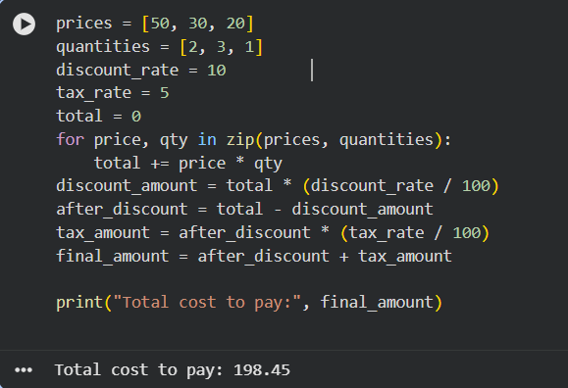

Experiment-7
Program:
import pandas as pd
order_data = pd.DataFrame({
"CustomerID": [1, 1, 2, 2, 3],
"OrderDate": ["2024-01-01", "2024-01-05", "2024-01-03", "2024-01-10", "2024-01-07"],
"Product": ["Pen", "Book", "Pen", "Pencil", "Book"],
"Quantity": [2, 1, 3, 4, 2]
})
orders_per_customer = order_data.groupby("CustomerID").size()
print(orders_per_customer)
avg_quantity = order_data.groupby("Product")["Quantity"].mean()
print(avg_quantity)
earliest = order_data["OrderDate"].min()
latest = order_data["OrderDate"].max()
print("Earliest:", earliest)
print("Latest:", latest)

Output:
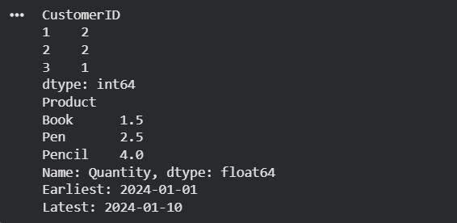

Experiment-8:
Program:
sales_data = pd.DataFrame({
"Product": ["Pen", "Book", "Pen", "Pencil", "Book", "Pen"],
"Quantity": [5, 3, 7, 2, 4, 6]
})
top_products = sales_data.groupby("Product")["Quantity"].sum().sort_values(ascending=False).head(5)
print(top_products)

Output:


Experiment-9:
Program:
property_data = pd.DataFrame({
"PropertyID": [1, 2, 3, 4],
"Location": ["Chennai", "Delhi", "Chennai", "Mumbai"],
"Bedrooms": [3, 5, 4, 6],
"Area": [1200, 2000, 1500, 3000],
"Price": [5000000, 8000000, 6000000, 12000000]
})
avg_price = property_data.groupby("Location")["Price"].mean()
print(avg_price)
count_large = property_data[property_data["Bedrooms"] > 4].shape[0]
print("Properties with >4 bedrooms:", count_large)
largest_property = property_data.loc[property_data["Area"].idxmax()]
print(largest_property)

Output:
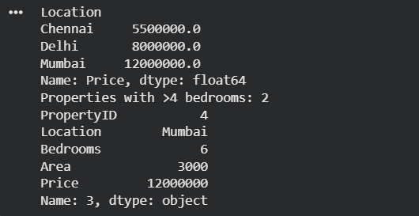

Experiment-10:
Program:
import matplotlib.pyplot as plt

months = ["Jan", "Feb", "Mar", "Apr", "May"]
sales = [20000, 25000, 30000, 28000, 35000]
plt.plot(months, sales)
plt.xlabel("Month")
plt.ylabel("Sales")
plt.title("Monthly Sales Line Plot")
plt.show()
plt.bar(months, sales)
plt.xlabel("Month")
plt.ylabel("Sales")
plt.title("Monthly Sales Bar Plot")
plt.show()

Output:
